|  |
| --- |
| | Please choose a lesson, or type 0 to return to course menu.  1: Principles of Analytic Graphs 2: Exploratory Graphs 3: Graphics Devices in R  4: Plotting Systems 5: Base Plotting System 6: Lattice Plotting System  7: Working with Colors 8: GGPlot2 Part1 9: GGPlot2 Part2  10: GGPlot2 Extras 11: Hierarchical Clustering 12: K Means Clustering  13: Dimension Reduction 14: Clustering Example 15: CaseStudy  Selection: 12  | Attemping to load lesson dependencies...  | Package ‘ggplot2’ loaded correctly!  | Package ‘fields’ loaded correctly!  | Package ‘jpeg’ loaded correctly!  | Package ‘datasets’ loaded correctly!  | | 0%  | K_Means_Clustering. (Slides for this and other Data Science courses may be found at github  | https://github.com/DataScienceSpecialization/courses/. If you care to use them, they must be downloaded as a zip file and  | viewed locally. This lesson corresponds to 04_ExploratoryAnalysis/kmeansClustering.)  ...  |== | 2%  | In this lesson we'll learn about k-means clustering, another simple way of examining and organizing multi-dimensional data.  | As with hierarchical clustering, this technique is most useful in the early stages of analysis when you're trying to get an  | understanding of the data, e.g., finding some pattern or relationship between different factors or variables.  ...  |===== | 4%  | R documentation tells us that the k-means method "aims to partition the points into k groups such that the sum of squares  | from points to the assigned cluster centres is minimized."  ...  |======= | 6%  | Since clustering organizes data points that are close into groups we'll assume we've decided on a measure of distance,  | e.g., Euclidean.  ...  |========= | 8%  | To illustrate the method, we'll use these random points we generated, familiar to you if you've already gone through the  | hierarchical clustering lesson. We'll demonstrate k-means clustering in several steps, but first we'll explain the general  | idea. |
|  |
| |  | | --- | | ... | |

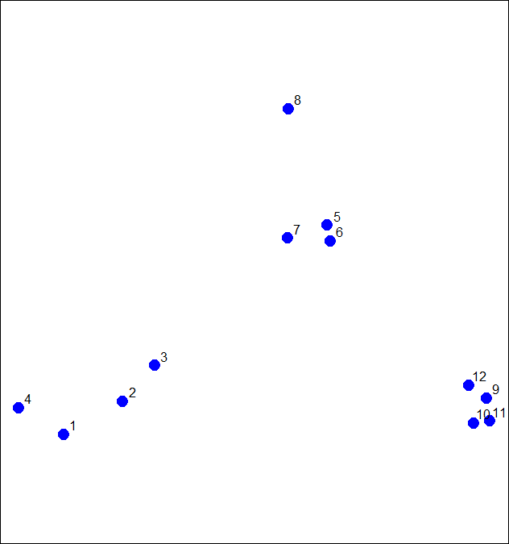

|============ | 10%

| As we said, k-means is a partioning approach which requires that you first guess how many clusters you have (or want). Once

| you fix this number, you randomly create a "centroid" (a phantom point) for each cluster and assign each point or

| observation in your dataset to the centroid to which it is closest. Once each point is assigned a centroid, you readjust

| the centroid's position by making it the average of the points assigned to it.

...

|============== | 12%

| Once you have repositioned the centroids, you must recalculate the distance of the observations to the centroids and

| reassign any, if necessary, to the centroid closest to them. Again, once the reassignments are done, readjust the positions

| of the centroids based on the new cluster membership. The process stops once you reach an iteration in which no adjustments

| are made or when you've reached some predetermined maximum number of iterations.

...

|================ | 14%

| As described, what does this process require?

1: A number of clusters

2: An initial guess as to cluster centroids

3: All of the others

4: A defined distance metric

Selection: 3

| Great job!

|=================== | 16%

| So k-means clustering requires some distance metric (say Euclidean), a hypothesized fixed number of clusters, and an

| initial guess as to cluster centroids. As described, what does this process produce?

1: An assignment of each point to a cluster

2: All of the others

3: A final estimate of cluster centroids

Selection: 2

| All that practice is paying off!

|===================== | 18%

| When it's finished k-means clustering returns a final position of each cluster's centroid as well as the assignment of each

| data point or observation to a cluster.

...

|======================= | 20%

| Now we'll step through this process using our random points as our data. The coordinates of these are stored in 2 vectors,

| x and y. We eyeball the display and guess that there are 3 clusters. We'll pick 3 positions of centroids, one for each

| cluster.

...

|========================== | 22%

| We've created two 3-long vectors for you, cx and cy. These respectively hold the x- and y- coordinates for 3 proposed

| centroids. For convenience, we've also stored them in a 2 by 3 matrix cmat. The x coordinates are in the first row and the

| y coordinates in the second. Look at cmat now.

> cmat

[,1] [,2] [,3]

[1,] 1 1.8 2.5

[2,] 2 1.0 1.5

| Excellent work!

|============================ | 24%

| The coordinates of these points are (1,2), (1.8,1) and (2.5,1.5). We'll add these centroids to the plot of our points. Do

| this by calling the R command points with 6 arguments. The first 2 are cx and cy, and the third is col set equal to the

| concatenation of 3 colors, "red", "orange", and "purple". The fourth argument is pch set equal to 3 (a plus sign), the

| fifth is cex set equal to 2 (expansion of character), and the final is lwd (line width) also set equal to 2.

> points(cx, cy, col = c("red", "orange", "purple"), pch = 3, cex = 2, lwd = 2)

| You got it!

|============================== | 26%

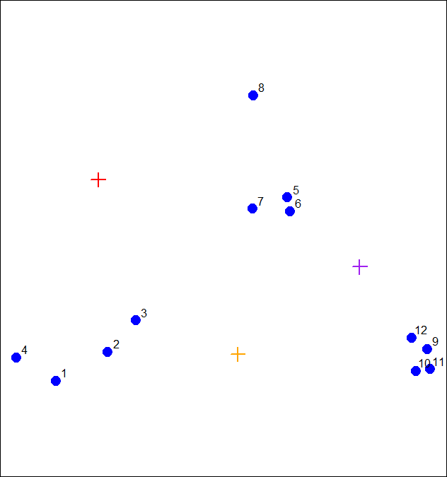

| We see the first centroid (1,2) is in red. The second (1.8,1), to the right and below the first, is orange, and the final

| centroid (2.5,1.5), the furthest to the right, is purple.

...

|================================ | 28%

| Now we have to calculate distances between each point and every centroid. There are 12 data points and 3 centroids. How

| many distances do we have to calculate?

1: 36

2: 15

3: 9

4: 108

Selection: 1

| You're the best!

|=================================== | 30%

| We've written a function for you called mdist which takes 4 arguments. The vectors of data points (x and y) are the first

| two and the two vectors of centroid coordinates (cx and cy) are the last two. Call mdist now with these arguments.

> mdist(x, y, cx, cy)

[,1] [,2] [,3] [,4] [,5] [,6] [,7] [,8] [,9] [,10] [,11] [,12]

[1,] 1.392885 0.9774614 0.7000680 1.264693 1.1894610 1.2458771 0.8113513 1.026750 4.5082665 4.5255617 4.8113368 4.0657750

[2,] 1.108644 0.5544675 0.3768445 1.611202 0.8877373 0.7594611 0.7003994 2.208006 1.1825265 1.0540994 1.2278193 1.0090944

[3,] 3.461873 2.3238956 1.7413021 4.150054 0.3297843 0.2600045 0.4887610 1.337896 0.3737554 0.4614472 0.5095428 0.2567247

| Great job!

|===================================== | 32%

| We've stored these distances in the matrix distTmp for you. Now we have to assign a cluster to each point. To do that we'll

| look at each column and ?

1: pick the minimum entry

2: pick the maximum entry

3: add up the 3 entries.

Selection: 1

| Excellent work!

|======================================= | 34%

| From the distTmp entries, which cluster would point 6 be assigned to?

1: 1

2: 3

3: none of the above

4: 2

Selection: 2

| Keep working like that and you'll get there!

|========================================== | 36%

| R has a handy function which.min which you can apply to ALL the columns of distTmp with one call. Simply call the R

| function apply with 3 arguments. The first is distTmp, the second is 2 meaning the columns of distTmp, and the third is

| which.min, the function you want to apply to the columns of distTmp. Try this now.

> apply(distTmp, 2, which.min)

[1] 2 2 2 1 3 3 3 1 3 3 3 3

| Nice work!

|============================================ | 38%

| You can see that you were right and the 6th entry is indeed 3 as you answered before. We see the first 3 entries were

| assigned to the second (orange) cluster and only 2 points (4 and 8) were assigned to the first (red) cluster.

...

|============================================== | 40%

| We've stored the vector of cluster colors ("red","orange","purple") in the array cols1 for you and we've also stored the

| cluster assignments in the array newClust. Let's color the 12 data points according to their assignments. Again, use the

| command points with 5 arguments. The first 2 are x and y. The third is pch set to 19, the fourth is cex set to 2, and the

| last, col is set to cols1[newClust].

> points(x, y, pch = 19, cex = 2, col = cols1[newClust])

| You're the best!

|================================================= | 42%

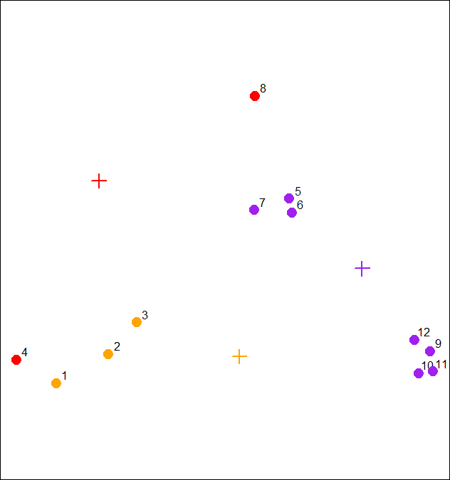

| Now we have to recalculate our centroids so they are the average (center of gravity) of the cluster of points assigned to

| them. We have to do the x and y coordinates separately. We'll do the x coordinate first. Recall that the vectors x and y

| hold the respective coordinates of our 12 data points.

...

|=================================================== | 44%

| We can use the R function tapply which applies "a function over a ragged array". This means that every element of the array

| is assigned a factor and the function is applied to subsets of the array (identified by the factor vector). This allows us

| to take advantage of the factor vector newClust we calculated. Call tapply now with 3 arguments, x (the data), newClust

| (the factor array), and mean (the function to apply).

> tapply(x, newClust, mean)

1 2 3

1.210767 1.010320 2.498011

| That's correct!

|===================================================== | 46%

| Repeat the call, except now apply it to the vector y instead of x.

> tapply(y, newClust, mean)

1 2 3

1.730555 1.016513 1.354373

| That's a job well done!

|======================================================== | 48%

| Now that we have new x and new y coordinates for the 3 centroids we can plot them. We've stored off the coordinates for you

| in variables newCx and newCy. Use the R command points with these as the first 2 arguments. In addition, use the arguments

| col set equal to cols1, pch equal to 8, cex equal to 2 and lwd also equal to 2.

> points(newCx, newCy, col = cols1, pch = 8, cex = 2, lwd = 2)

| Perseverance, that's the answer.

|========================================================== | 50%

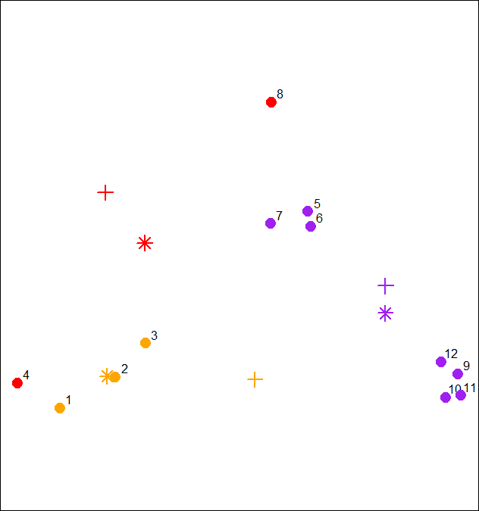

| We see how the centroids have moved closer to their respective clusters. This is especially true of the second (orange)

| cluster. Now call the distance function mdist with the 4 arguments x, y, newCx, and newCy. This will allow us to reassign

| the data points to new clusters if necessary.

> mdist(x, y, newCx, newCy)

[,1] [,2] [,3] [,4] [,5] [,6] [,7] [,8] [,9] [,10] [,11] [,12]

[1,] 0.98911875 0.539152725 0.2901879 1.0286979 0.7936966 0.8004956 0.4650664 1.028698 3.3053706 3.282778 3.5391512 2.9345445

[2,] 0.09287262 0.002053041 0.0734304 0.2313694 1.9333732 1.8320407 1.4310971 2.926095 3.5224442 3.295301 3.5990955 3.2097944

[3,] 3.28531180 2.197487387 1.6676725 4.0113796 0.4652075 0.3721778 0.6043861 1.643033 0.2586908 0.309730 0.3610747 0.1602755

| Keep up the great work!

|============================================================ | 52%

| We've stored off this new matrix of distances in the matrix distTmp2 for you. Recall that the first cluster is red, the

| second orange and the third purple. Look closely at columns 4 and 7 of distTmp2. What will happen to points 4 and 7?

1: They will both change clusters

2: Nothing

3: They will both change to cluster 2

4: They're the only points that won't change clusters

Selection: 1

| You're the best!

|=============================================================== | 54%

| Now call apply with 3 arguments, distTmp2, 2, and which.min to find the new cluster assignments for the points.

> apply(distTmp2, 2, which.min)

[1] 2 2 2 2 3 3 1 1 3 3 3 3

| You are doing so well!

|================================================================= | 56%

| We've stored off the new cluster assignments in a vector of factors called newClust2. Use the R function points to recolor

| the points with their new assignments. Again, there are 5 arguments, x and y are first, followed by pch set to 19, cex to

| 2, and col to cols1[newClust2].

> points(x, y, pch = 19, cex = 2, col = cols1[newClust2])

| Excellent work!

|=================================================================== | 58%

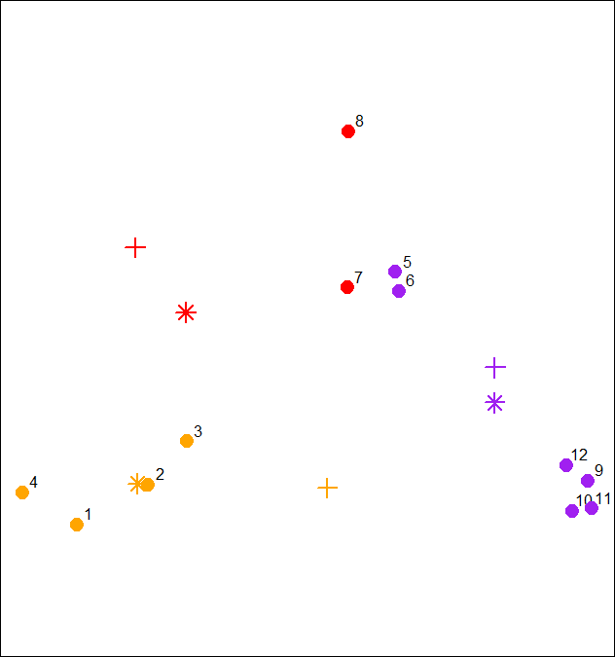

| Notice that points 4 and 7 both changed clusters, 4 moved from 1 to 2 (red to orange), and point 7 switched from 3 to 2

| (purple to red).

...

|====================================================================== | 60%

| Now use tapply to find the x coordinate of the new centroid. Recall there are 3 arguments, x, newClust2, and mean.

> tapply(x, newClust2, mean)

1 2 3

1.8878628 0.8904553 2.6001704

| You are doing so well!

|======================================================================== | 62%

| Do the same to find the new y coordinate.

> tapply(y, newClust2, mean)

1 2 3

2.157866 1.006871 1.274675

| Excellent work!

|========================================================================== | 64%

| We've stored off these coordinates for you in the variables finalCx and finalCy. Plot these new centroids using the points

| function with 6 arguments. The first 2 are finalCx and finalCy. The argument col should equal cols1, pch should equal 9,

| cex 2 and lwd 2.

> points(finalCx, finalCy, col = cols1, pch = 9, cex = 2, lwd = 2)

| Keep up the great work!

|============================================================================= | 66%

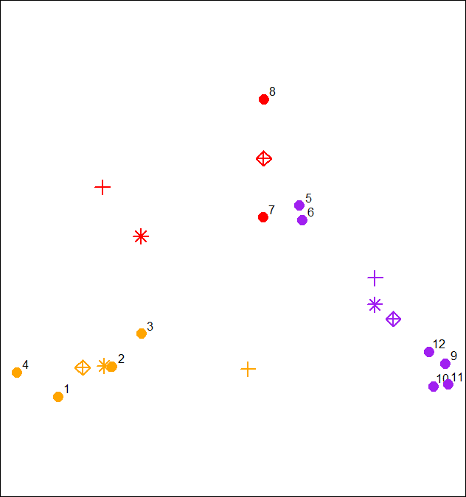

| It should be obvious that if we continued this process points 5 through 8 would all turn red, while points 1 through 4 stay

| orange, and points 9 through 12 purple.

...

|=============================================================================== | 68%

| Now that you've gone through an example step by step, you'll be relieved to hear that R provides a command to do all this

| work for you. Unsurprisingly it's called kmeans and, although it has several parameters, we'll just mention four. These are

| x, (the numeric matrix of data), centers, iter.max, and nstart. The second of these (centers) can be either a number of

| clusters or a set of initial centroids. The third, iter.max, specifies the maximum number of iterations to go through, and

| nstart is the number of random starts you want to try if you specify centers as a number.

...

|================================================================================= | 70%

| Call kmeans now with 2 arguments, dataFrame (which holds the x and y coordinates of our 12 points) and centers set equal to

| 3.

> kmeans(dataFrame, centers = 3)

K-means clustering with 3 clusters of sizes 4, 4, 4

Cluster means:

x y

1 0.8904553 1.0068707

2 2.8534966 0.9831222

3 1.9906904 2.0078229

Clustering vector:

[1] 1 1 1 1 3 3 3 3 2 2 2 2

Within cluster sum of squares by cluster:

[1] 0.34188313 0.03298027 0.34732441

(between_SS / total_SS = 93.6 %)

Available components:

[1] "cluster" "centers" "totss" "withinss" "tot.withinss" "betweenss" "size" "iter"

[9] "ifault"

| You're the best!

|==================================================================================== | 72%

| The program returns the information that the data clustered into 3 clusters each of size 4. It also returns the coordinates

| of the 3 cluster means, a vector named cluster indicating how the 12 points were partitioned into the clusters, and the sum

| of squares within each cluster. It also shows all the available components returned by the function. We've stored off this

| data for you in a kmeans object called kmObj. Look at kmObj$iter to see how many iterations the algorithm went through.

> kmObj$iter

[1] 2

| You got it!

|====================================================================================== | 74%

| Two iterations as we did before. We just want to emphasize how you can access the information available to you. Let's plot

| the data points color coded according to their cluster. This was stored in kmObj$cluster. Run plot with 5 arguments. The

| data, x and y, are the first two; the third, col is set equal to kmObj$cluster, and the last two are pch and cex. The first

| of these should be set to 19 and the last to 2.

> plot(x, y, col = kmObj$cluster, pch = 19, cex = 2)

| You're the best!

|======================================================================================== | 76%

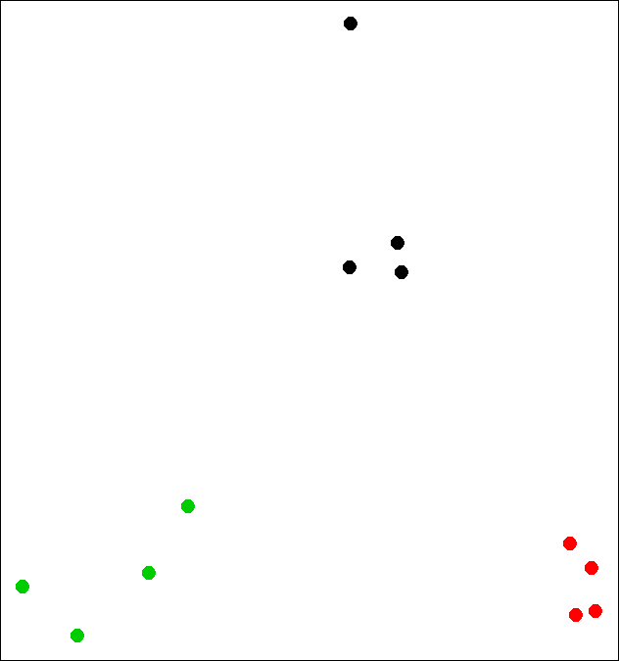

| Now add the centroids which are stored in kmObj$centers. Use the points function with 5 arguments. The first two are

| kmObj$centers and col=c("black","red","green"). The last three, pch, cex, and lwd, should all equal 3.

> points(kmObj$centers, col = c("black", "red", "green"), pch = 3, cex = 3, lwd = 3)

| You nailed it! Good job!

|========================================================================================== | 78%

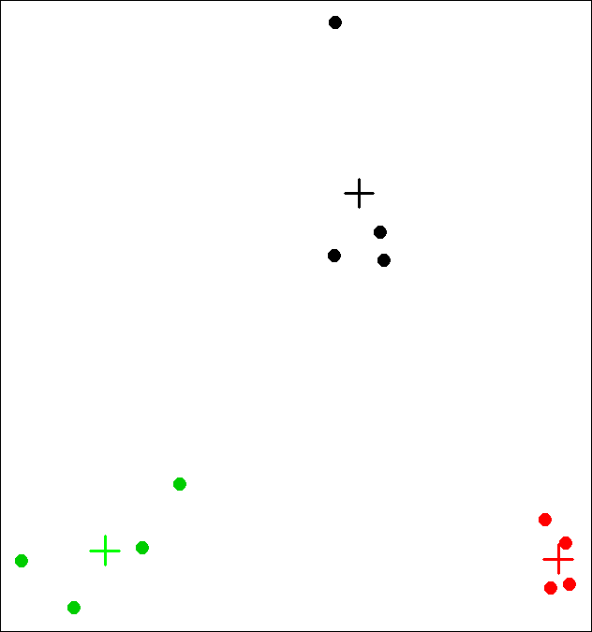

| Now for some fun! We want to show you how the output of the kmeans function is affected by its random start (when you just

| ask for a number of clusters). With random starts you might want to run the function several times to get an idea of the

| relationships between your observations. We'll call kmeans with the same data points (stored in dataFrame), but ask for 6

| clusters instead of 3.

...

|============================================================================================= | 80%

| We'll plot our data points several times and each time we'll just change the argument col which will show us how the R

| function kmeans is clustering them. So, call plot now with 5 arguments. The first 2 are x and y. The third is col set equal

| to the call kmeans(dataFrame,6)$cluster. The last two (pch and cex) are set to 19 and 2 respectively.

> plot(x, y, col = kmeans(dataFrame,6)$cluster, pch = 19, cex = 2)

| You got it!

|=============================================================================================== | 82%

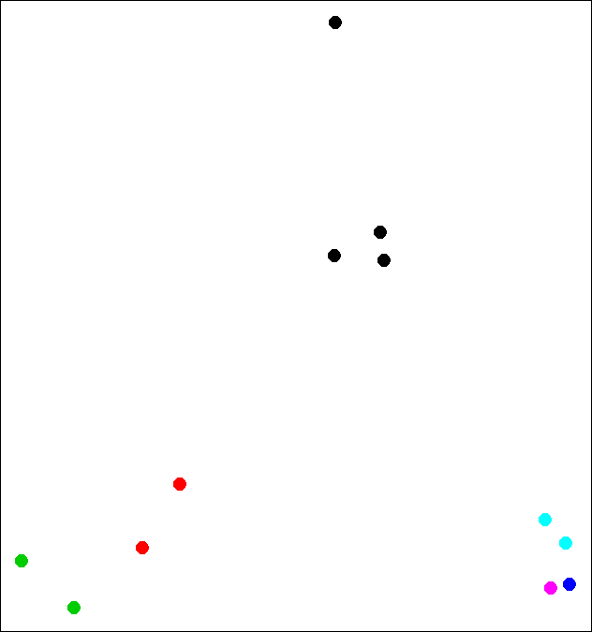

| See how the points cluster? Now recall your last command and rerun it.

> plot(x, y, col = kmeans(dataFrame,6)$cluster, pch = 19, cex = 2)

| That's a job well done!

|================================================================================================= | 84%

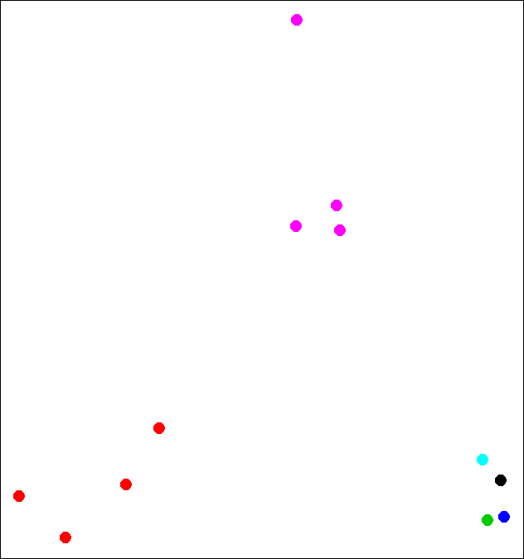

| See how the clustering has changed? As the Teletubbies would say, "Again! Again!"

> plot(x, y, col = kmeans(dataFrame,6)$cluster, pch = 19, cex = 2)

| That's a job well done!

|==================================================================================================== | 86%

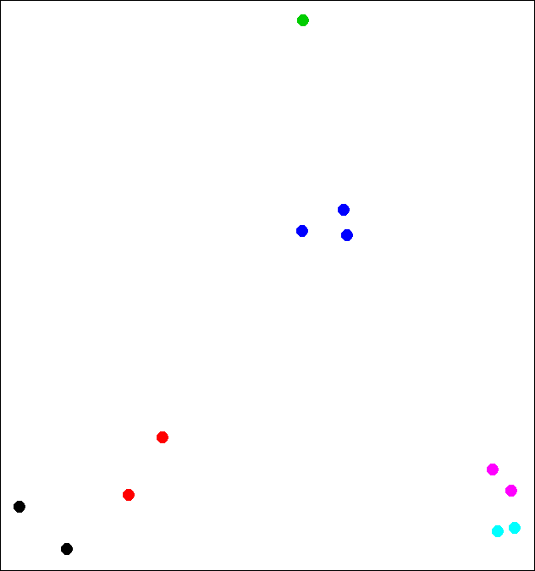

| So the clustering changes with different starts. Perhaps 6 is too many clusters? Let's review!

...

|====================================================================================================== | 88%

| True or False? K-means clustering requires you to specify a number of clusters before you begin.

1: True

2: False

Selection: 1

| You nailed it! Good job!

|======================================================================================================== | 90%

| True or False? K-means clustering requires you to specify a number of iterations before you begin.

1: False

2: True

Selection: 1

| Keep up the great work!

|=========================================================================================================== | 92%

| True or False? Every data set has a single fixed number of clusters.

1: False

2: True

Selection: 1

| You got it right!

|============================================================================================================= | 94%

| True or False? K-means clustering will always stop in 3 iterations

1: False

2: True

Selection: 1

| That's the answer I was looking for.

|=============================================================================================================== | 96%

| True or False? When starting kmeans with random centroids, you'll always end up with the same final clustering.

1: True

2: False

Selection: 2

| You are amazing!

|================================================================================================================== | 98%

| Congratulations! We hope this means you found this lesson oK.

...

|====================================================================================================================| 100%